Analysis of World Bank - IDA Statement of Credits, Grants and Guarantees - Historical Data via SQL

Introduction
This is part of Finance project using SQL. When I downloaded csv file, it was pretty large file where number rows 1.41 million and number of columns is 30. I have used SQL heavily to analyze IDA Statement of Credits, Grants and Guarantees - Historical Data which is part of World Bank.
Data
The dataset comes directly from the World Bank of Nov 2025. You can find datasets from its website directly if you want to analyze yourself.

Tools that I used to analyze this dataset. I used Excel to clean up data if there is duplicate or not, SQL to analyze data and I ran on CSVFiddle.io. This tool cannot run the large dataset so that I used LIMIT clause on my command line.

Data Dictionary that has been named in the project as follows:
Region, Country / Economy, Borrower, Credit Status, Original Principal Amount (US$), Disbursed Amount (US$), Undisbursed Amount (US$), Repaid to IDA (US$), Due to IDA (US$), Borrower's Obligation (US$), and Board Approval Date.

These are Business Questions that I analyzed:
- Show all transactions from Honduras.
- How many total transactions per country?
- Which regions receive the highest loan amounts?
- How strong is loan repayment performance?

Technical Analysis By SQL
  - Show all transactions from Honduras.
To identify all transactions from Honduras, I executed the following SQL
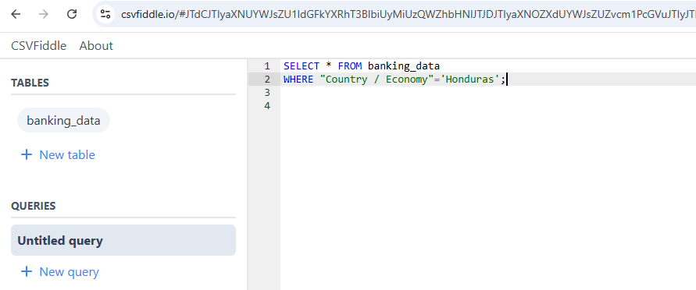

After I executed the SQL, you can see the Country/Economy, Borrower, and Credit Status as shown below.
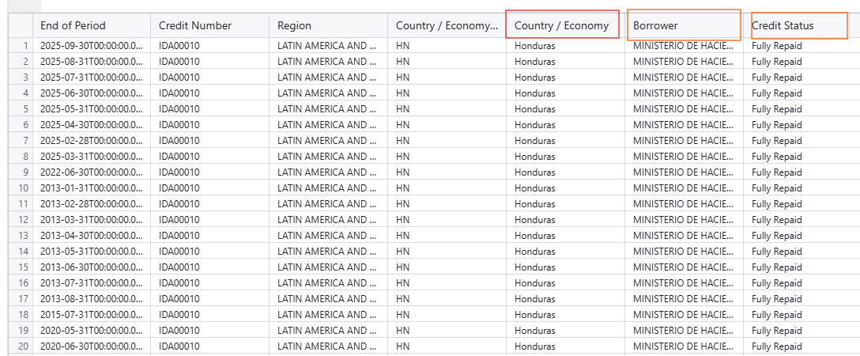

  - How many total transactions per country?
To identify the total transactions per country, I executed the following SQL.
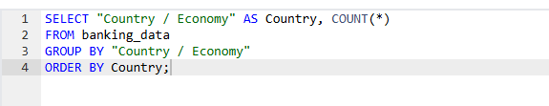

You can see total number of countries145 with their total transactions; to achieve this one, I applied GROUP BY and ORDER BY function.

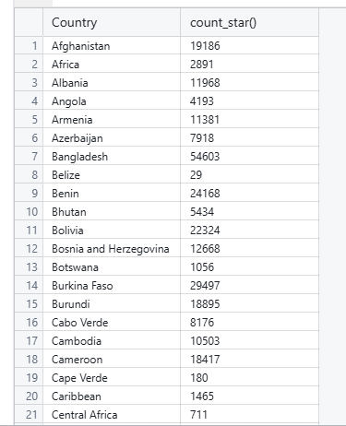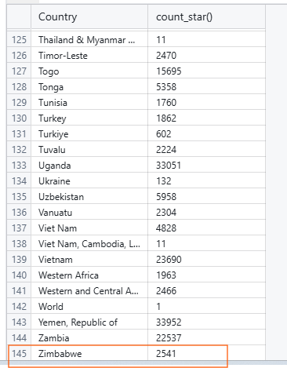

  - The highest loan amounts by Region
To identify the Region based on the highest loan amount, I executed following SQL
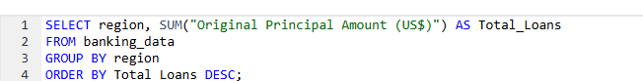

Then you can see South Asia Region has the Highest Loan Amount and other has least amount.
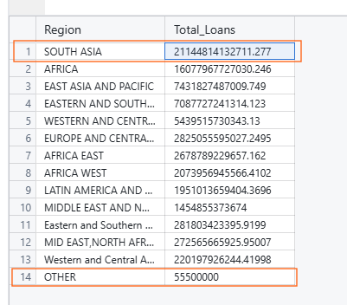

- Analysis of Loan Repayment by Credit Status
To identify this condition, I executed thie following SQL

You can see Credit Status, total_repaid, and total_due as well as Fully Repaid is 7.28 T, Repaid is 1.73 T, Repaying is 7.73 T etc.
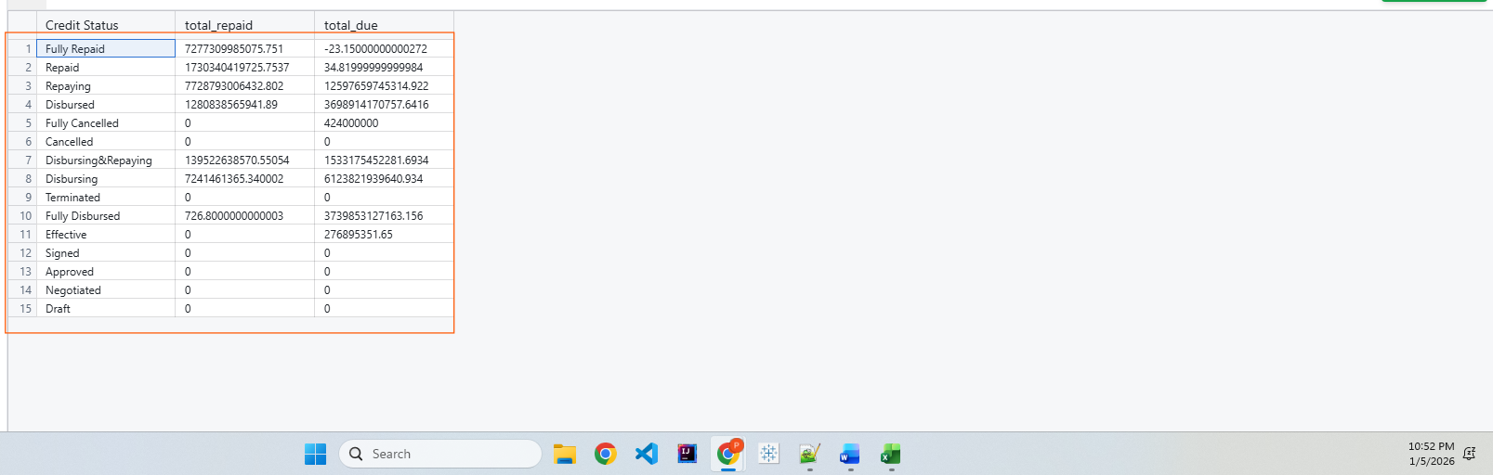

Conclusion
By Using SQL to analyze the World Bank data, I learned and applied:
Show all transaction of Honduras country such as the Country/Economy, Borrower, and Credit Status as shown below.
There are 145 countries total with total transactions.
The South Asia Region has the Highest Loan Amount and others have the least amount.
Loan Repayment by Credit Status, total_repaid, and total_due as well as Fully Repaid is 7.28 T, Repaid is 1.73 T, Repaying is 7.73 T etc.

Let's Connect
Thank you for taking the time to read my analysis. I’d love to turn this into a conversation if you have feedback, concerns, suggestions, or questions, please share them in the comments.
I would like to connect with you all on LinkedIn

